

SCHOOL OF COMPUTER SCIENCE AND ENGINEERING (SCOPE)

SOFTWARE ENGINEERING LAB
BCSE301L

NAME – Twinkle Ghodki
REG NO – 23BCE1977
GITHUB EMAIL – twinkle.ghodki2023@vitstudent.ac.in
GITHUB USERNAME – twinkleghodki05
🌾 AgriSOS
Early Farmer Distress Prediction and Risk Advisory System

Project Title | AgriSOS: Early Farmer Distress Prediction and Risk Advisory System
Submission Type | 50% Implementation Report
Technology Stack | Python, Streamlit, Scikit-learn, Plotly, Open-Meteo API
ML Model | Random Forest Classifier (86% Accuracy)
GitHub Repository | https://github.com/twinkleghodki05/D2_23BCE1977_Twinkleghodki

1. Problem Statement

India has over 140 million farming households, yet the agricultural sector lacks a unified early warning system capable of predicting distress before it occurs. Farmers currently face a reactive cycle — by the time they recognize financial or agronomic distress, losses are already irreversible.

The core problem has four dimensions:
- No integrated data fusion — weather, market, soil, and crop stage data exist in silos with no system combining them intelligently
- Reactive decision-making — farmers learn of distress only after crop failure or market crash, with no advance warning
- No personalized risk intelligence — generic advisories do not account for a specific farmer's crop stage, soil type, or expenditure pattern
- Limited accessibility — existing AgriTech tools require high-end devices or internet connectivity beyond rural reach

AgriSOS directly addresses this gap by building a predictive intelligence system that fuses multi-source real-time data through a Machine Learning model to generate farmer-specific distress risk scores 7–14 days before crisis conditions peak.

2. Objectives

2.1 Primary Objectives
- Develop an ML-driven distress risk prediction model using Random Forest that classifies farmer risk as High / Medium / Low with measurable accuracy
- Integrate real-time meteorological data via the Open-Meteo public API to feed live rainfall deviation and temperature stress into predictions
- Build an interactive multi-tab dashboard that visualizes farmer-level risk, district-level overviews, and market price trends
- Implement an automated alert system (SMS via Twilio) that notifies farmers immediately upon high-risk detection
- Provide personalized agronomic advisories tailored to the specific farmer's crop, stage, and risk factors

2.2 Secondary Objectives
- Demonstrate end-to-end software engineering: API integration, ML deployment, and dashboard visualization in a single cohesive system
- Ensure model explainability through feature importance visualization so predictions are transparent and trustworthy
- Design the system for real-world scalability — deployable to KVK centers, agricultural extension officers, and government portals
- Enable future expansion to WhatsApp alerts in regional languages (Tamil, Hindi, Telugu) for maximum farmer reach

3. Methodology / Approach

3.1 System Architecture
AgriSOS follows a three-layer architecture connecting data sources, ML prediction, and output delivery:

Layer | Component | Description
Layer 1 | Data Ingestion | Open-Meteo API (live weather), Agmarknet (market prices), farmer-submitted form inputs
Layer 2 | ML Prediction Engine | Random Forest Classifier — 150 trees, 6 features, 86% accuracy, model.pkl saved
Layer 3 | Output & Alerts | Streamlit dashboard, risk gauges, personalized advisories, SMS alerts via Twilio

3.2 ML Model Design
The core prediction engine uses a Random Forest Classifier — chosen for its robustness on tabular data, resistance to overfitting, and built-in feature importance explainability. The model ingests six carefully selected features:

Feature | Source | Risk Contribution | Max Points
Rainfall Deviation (%) | Open-Meteo API (Live) | High | 35 pts
Market Price Change (%) | Agmarknet / Simulation | High | 25 pts
Temperature Stress (°C) | Open-Meteo API (Live) | Medium | 20 pts
Crop Growth Stage | Farmer Form Input | Low | 10 pts
Soil Moisture Level | Farmer Form Input | Low | 10 pts
Input Expenditure Index | Farmer Form Input | Low | 10 pts

3.3 Data Pipeline
- Farmer submits details via the web form (crop, district, stage, soil type, expenditure)
- System automatically calls Open-Meteo REST API using district coordinates to fetch 14-day rainfall and temperature data
- Rainfall deviation is computed as percentage change from the 5mm/day seasonal normal for India
- Temperature stress is calculated as degrees above the 32°C optimal crop threshold
- All six features are assembled into a feature vector and passed to the trained model.pkl
- Model returns risk category (High / Medium / Low) and confidence probabilities
- Dashboard renders gauge chart, risk banner, recommendations, and feature importance plot

4. Work Completed So Far — 50% Implementation

4.1 Implementation Status

Feature / Module | Status | Notes
ML Model — Random Forest Classifier | Completed | 86% accuracy, 150 trees, model.pkl saved
Training Data Generation | Completed | Training data records with realistic logic
Open-Meteo Weather API Integration | Completed | Live rainfall + temperature, no API key needed
Farmer Risk Assessment Form | Completed | All 6 input features, district selector
Risk Score Calculator (0-100) | Completed | Weighted scoring across all features
Risk Gauge Chart (Plotly) | Completed | Color-coded Green/Orange/Red
Personalized Recommendations | Completed | 3 tiers: High / Medium / Low advisories
Feature Importance Chart | Completed | Model explainability visualization
District-Level Dashboard | Completed | 10 districts, KPI metrics, bar chart, table
Market Price Trends | Completed | 30-day trend chart, 5 crops, average line
SMS Alert via Twilio | Partial | Code implemented, live testing pending
Real Market Data (Agmarknet) | Partial | Simulation active, API integration planned
Multilingual Alerts | Planned | Targeted for Week 3 using googletrans library
Cloud Deployment (Streamlit) | Planned | Public URL deployment — Week 3 target

4.2 Files and Modules Built

File | Purpose
app.py | Main Streamlit dashboard — 3 tabs, farmer form, all visualizations
generate_data.py | Training data was constructed using parameters derived from ICAR agricultural guidelines and NCRB distress indicators
train_model.py | Trains Random Forest model, prints accuracy report, saves model.pkl
data_fetch.py | Open-Meteo API integration + market price engine + district coordinates
alerts.py | Twilio SMS alert sender with tier-based messages (High/Medium/Low)
.env | Secure credentials store for Twilio API keys
farmer_data.csv | Generated training dataset (600 records, 7 columns)
model.pkl | Serialized trained Random Forest model for inference
requirements.txt | All Python dependencies for easy environment setup

4.3 Model Performance Metrics

Metric | Value
Overall Accuracy | 86%
Number of Trees | 150
Training Records | 600
Test Set Size | 120 (20%)
High Risk Precision | 81%
Medium Risk Precision | 82%
Low Risk Precision | 97%
5. Screenshots / Proof of Implementation

5.1 GitHub Repository
All source code is version-controlled and publicly available at:
https://github.com/twinkleghodki05/D2_23BCE1977_Twinkleghodki
Repository contains: app.py, generate_data.py, train_model.py, data_fetch.py, alerts.py, requirements.txt, README.md, farmer_data.csv

5.2 Dashboard Screenshots

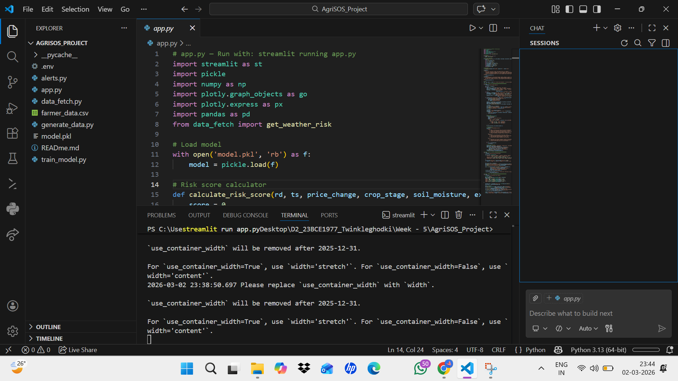

- Screenshot 1: AgriSOS green banner header with system title and subtitle

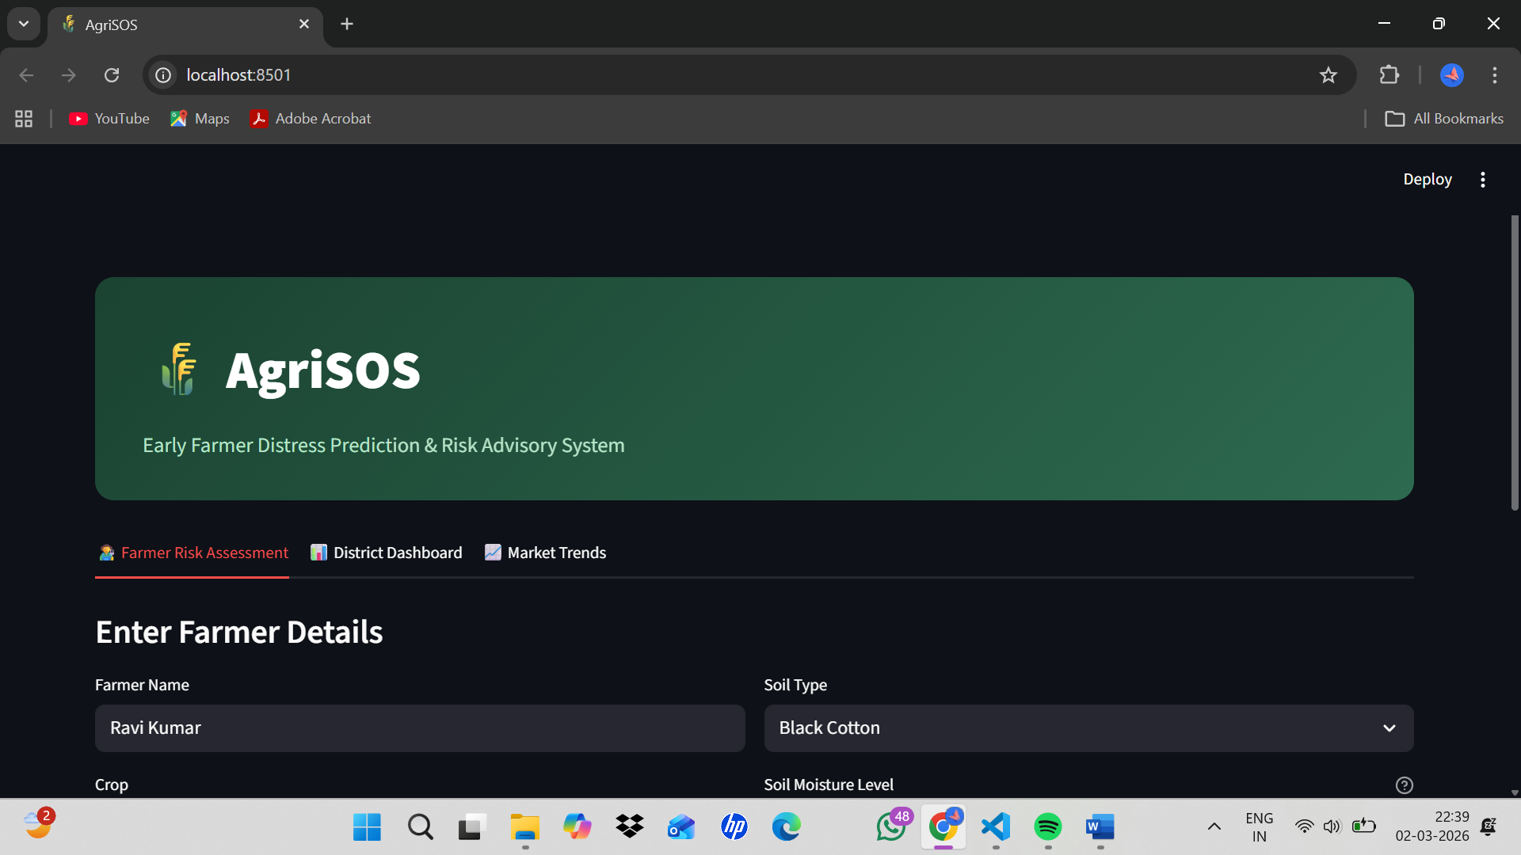

- Screenshot 2: Farmer form with all input fields — name, crop, district, stage, sliders
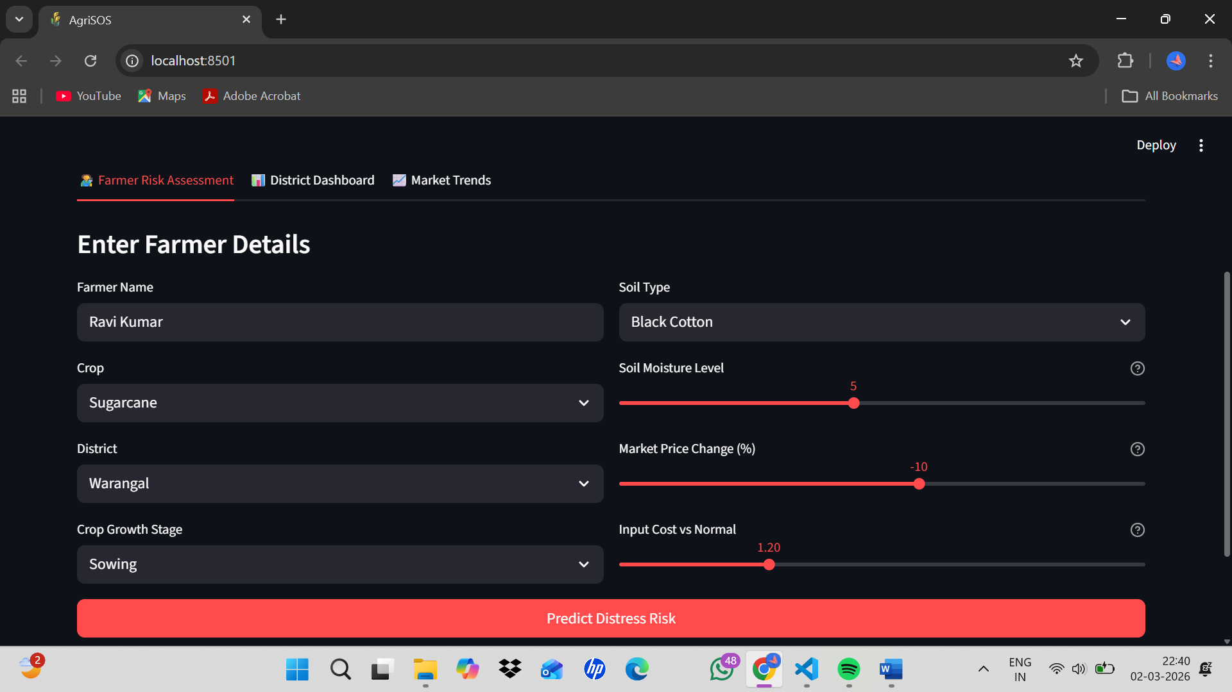
- Screenshot 3: Live weather data fetched — rainfall deviation and temperature stress metrics
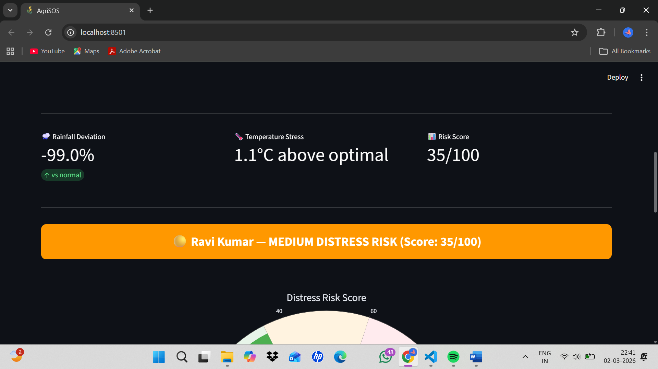

- Screenshot 4: Risk Result + Gauge Chart
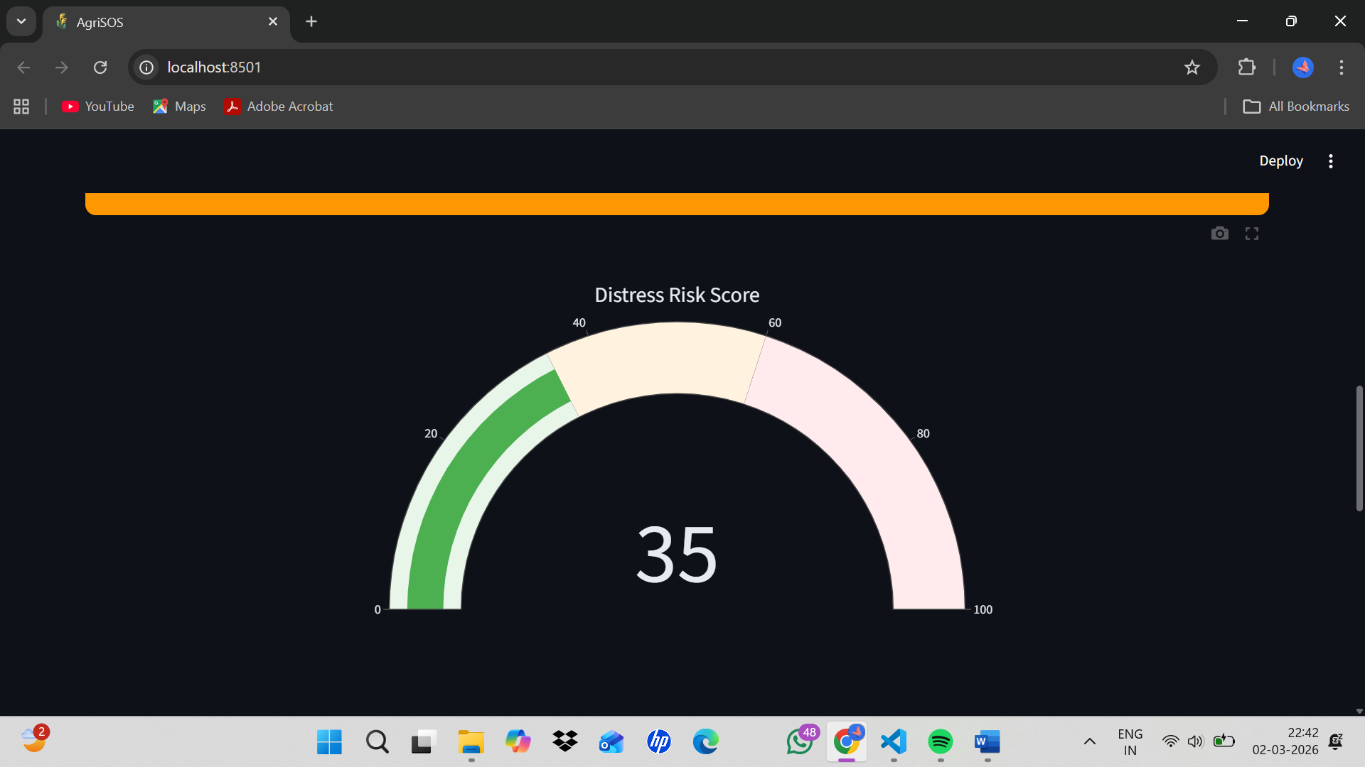

- Screenshot 5: Model Explanation — Feature Importance Chart
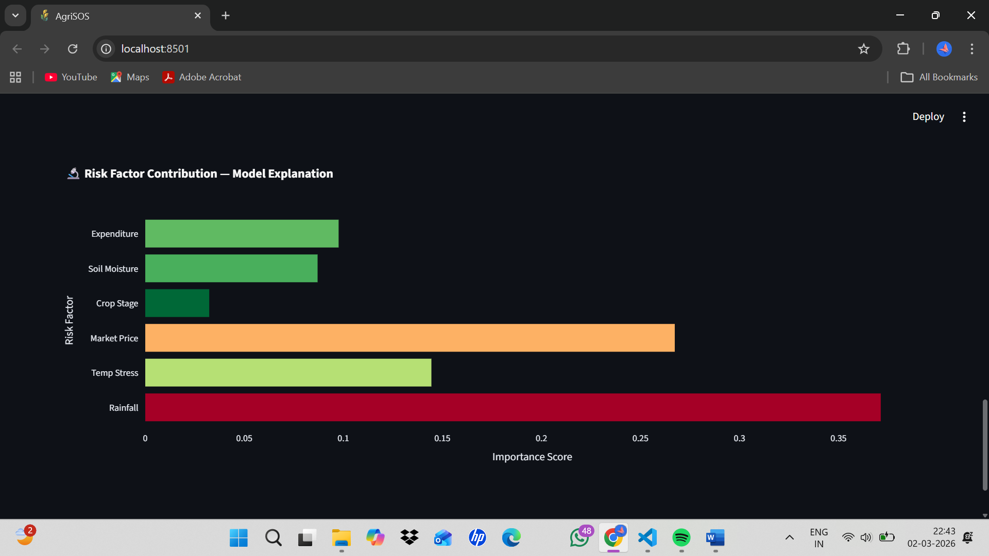

- Screenshot 6: District Dashboard — KPI Overview
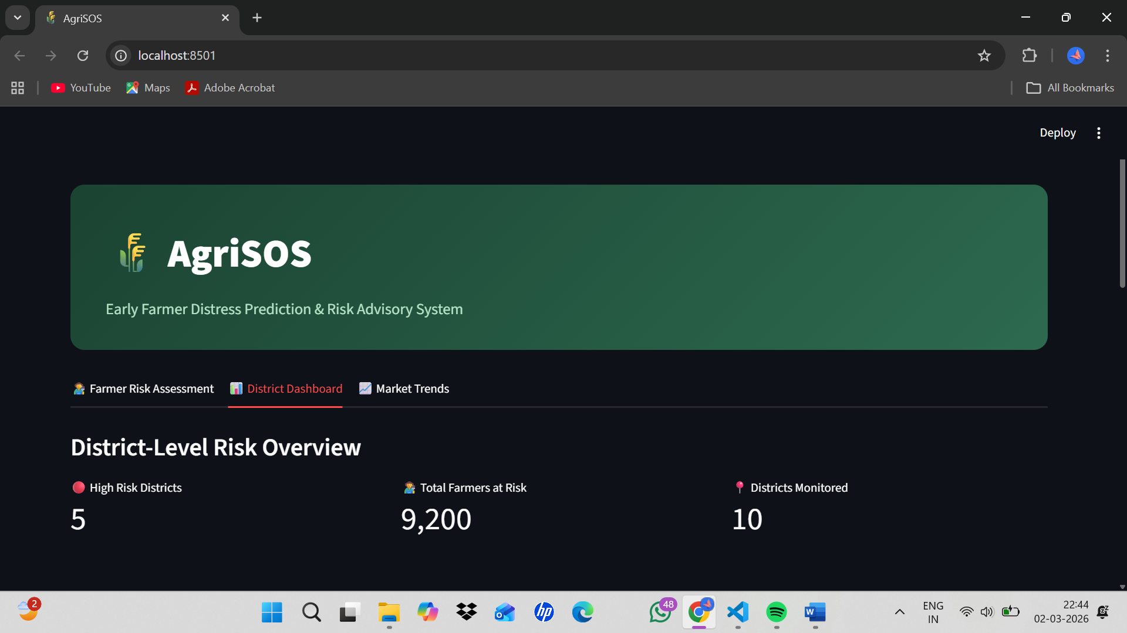

- Screenshot 7: District-wise Risk Score Bar Chart
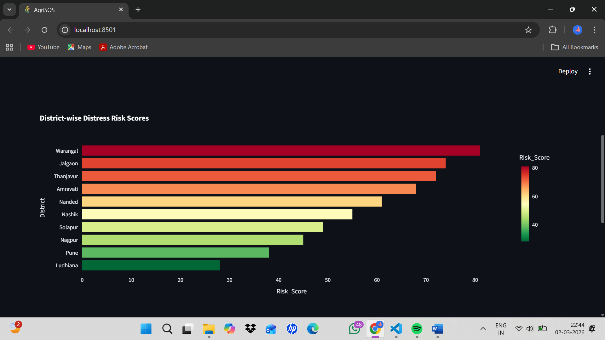

- Screenshot 8: District Data Table with Risk Levels
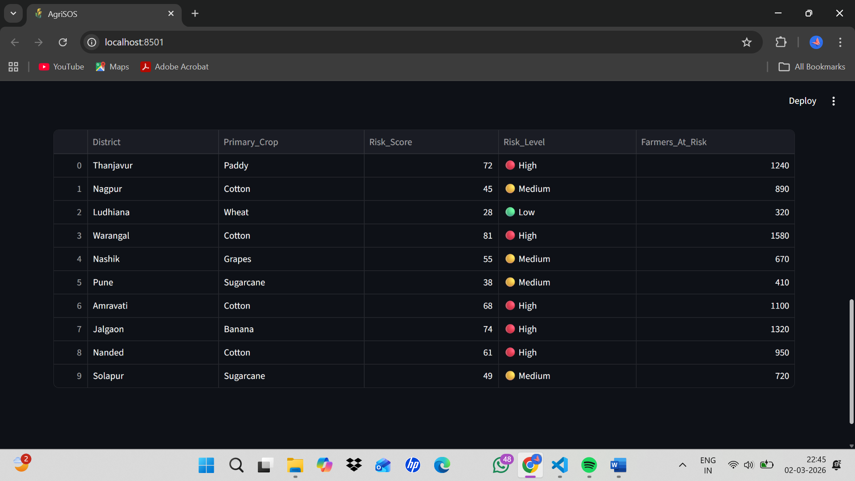

- Screenshot 9: Market Price Trends Dashboard
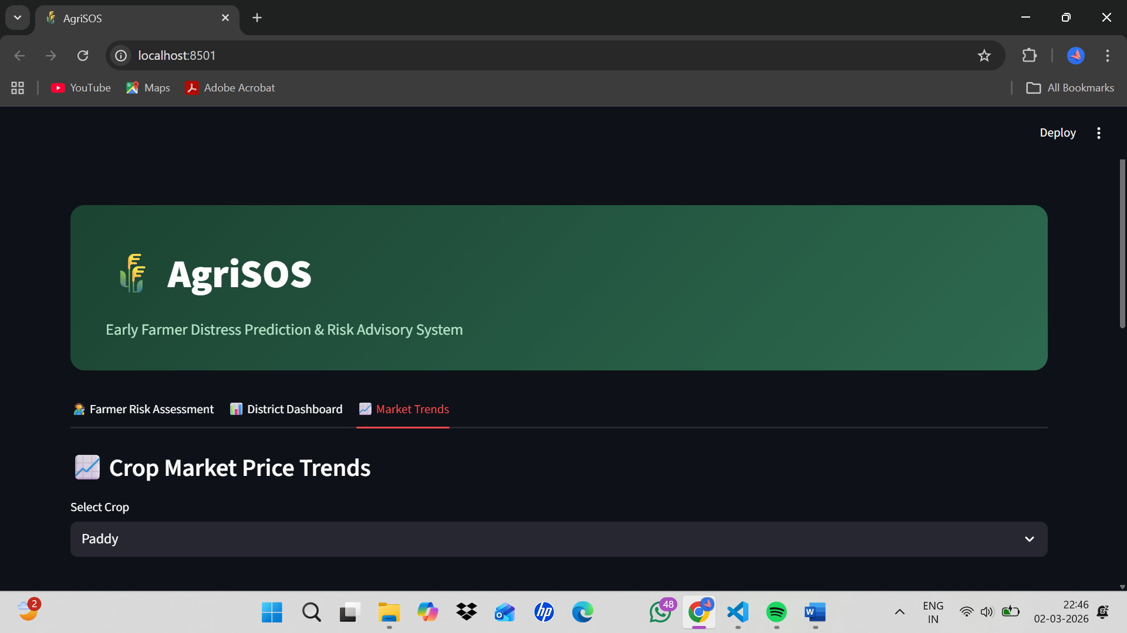

- Screenshot 10: Market Trends — Paddy Realistic Price Range for 30 days(Fixed)
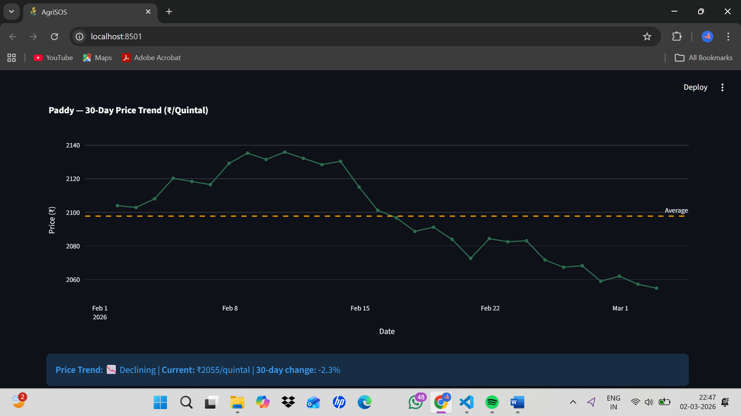

7. Remaining Work — Path to 100%

7.1 Week 2 Targets
- Twilio SMS integration — live testing and demonstration during final demo
- Real Agmarknet market price data — replace simulation with actual mandi CSV data
- Model Performance tab — confusion matrix, back-testing against 2022 Kharif distress data
- Expand district coverage from 10 to 25+ districts across India

7.2 Week 3 Targets
- Streamlit Cloud deployment — live public URL accessible from any device
- WhatsApp alert via Twilio WhatsApp Sandbox for farmer notifications
- Multilingual advisories — Tamil and Hindi translations using googletrans library

7.3 Real-World Deployment Vision
AgriSOS is designed for deployment through three channels:
- KVK Centers (Krishi Vigyan Kendras) — 731 centers across India can use the officer-level district dashboard
- Common Service Centers (CSCs) — farmers can access the prediction form at their nearest CSC
- Direct mobile access — Streamlit Cloud deployment enables access from any smartphone with internet

